**Surveying and Managing for Curly Leaf Pondweed**

**Hand Pulling 2021**

***Rice / Turtle River/ Pike Lake***

*Here is a list of equipment for volunteer teams of* ***(2-3 people****) for hand pulling Curly Leaf Pondweed.*

***Equipment List***

☐ Boat (canoe, kayak, fishing boat, paddle boat, etc.)

☐ Personal floatation device (PFD) 1 for each person, plus 1-throwable.

☐ Long handled garden rake (for deep areas attach rope)

☐ Lake / River map for marking suspect curly-leaf pondweed beds and keeping track of where you have been. <https://arcg.is/8vr9n>

☐ Pencil for marking on map location of CLP

☐ Dry bag or zip lock bag for paper forms, phones, dry cloths.

☐ Clip board or other hard surface for writing

☐ Ziploc bags for plants specimens in question

☐ Waterproof sharpie pen (to write on Ziploc bags or Flagging tap)

☐ Plant bags with water filter. Burlap sack, mess laundry bag or professional AIS bag

☐ GPS unit for recording location (optional) - Kobocollect Invasive Species App. (Zach Wilson provided) or google forms see “New population reporting form”

☐ Polarized sunglasses (optional but a good idea)

☐ Plant Identification Book (pick up packet from library or Zach Wilson)

☐ Water shoes or waders. (Feet must be protected)

☐ First Aid Kit

☐ Aqua-view scope (optional). Duane has built a couple

☐ A copy of appropriate report form(s) (found at the end of this section and at <http://dnr.wi.gov/lakes/monitoring/forms.aspx>, depending on the type of monitoring you are doing:

**Additional Information for surveyors and hand pulling volunteers.**

* SAFETY is extremely important…… make sure to tell a friend or family member before venturing out to do survey or hand pulling work. Please practice social distancing, clean surfaces, and equipment when shared and wear face masks when encountering others.
* Respect private property always. We want to build partnerships.

☐ Volunteer Hours Reporting Form: For Grant Match: See Link Below

<https://pikelakeneighbors.org/ais-control-project/volunteer-labor-worksheet/>

New CLP Population Reporting Form: <https://docs.google.com/forms/d/e/1FAIpQLSdfpzp-L7RoXqpVciyIbfJpodVgLCK6J0FBp45c78Ji9QrNHw/viewform?usp=sf_link>

***Rice, Turtle, and Pike Lake Population Map***

Weblink to map: <https://arcg.is/8vr9n>

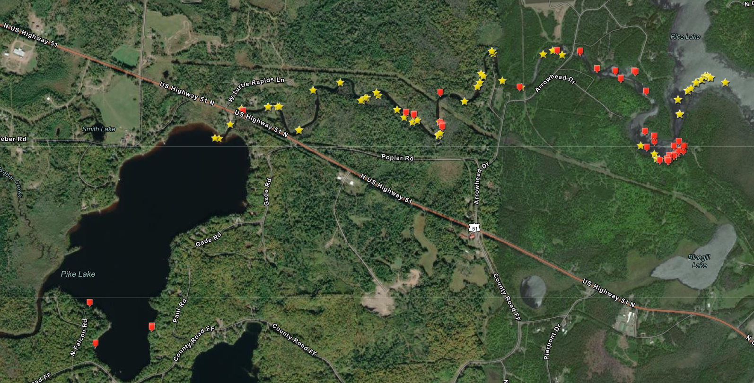

***Video Trainings***

Discovery Center AIS

<https://www.youtube.com/watch?v=k-z9B-LFNX8>

Montana CLP video

<https://www.youtube.com/watch?v=vn6YqdKpDnA>