Pike Lake

Pike Lake is a 214-acre lake located in Iron County. It has a maximum depth of 80 feet. Fish include Musky, Panfish, Largemouth Bass, Smallmouth Bass, Northern Pike and Walleye.
Hydrologic Type: Drainage
Miles of Shoreline: 2.95
Secchi Reading: 6 feet
Water Level: Slightly High
Watershed: Turtle River Watershed
Chart 1: Pike lake is a highly developed lake with unique hydrologic qualities. It has an inlet and an outlet. CWH surveys showed 49 total CWH points with 33 no branches, 12 few branches and 4 full crowns. The current CWH ratios are 16.61/mile and 0.23/acre

Figure 1: A table classifying how the logs were positioned in the water. 2 of the logs were less than five feet of length underwater and 46 had at least five feet underwater. Of those logs 22 were entirely below the high-water level and 27 were touching shore with at least five feet underwater.
In Water | 0-less than 5 ft of log underwater | 2
 | 1-at least 5 ft. of log underwater | 46
Touch Shore | 0-entirely below high-water level | 22
 | 1-at least 5-ft of log is currently underwater | 27

Figure 2: This is a map depicting the location and classification of woody habitat around Pike lake. Notice the lack of full crown trees and trees with a few branches on them. Also notice the lack of woody habitat along the northwest shoreline.
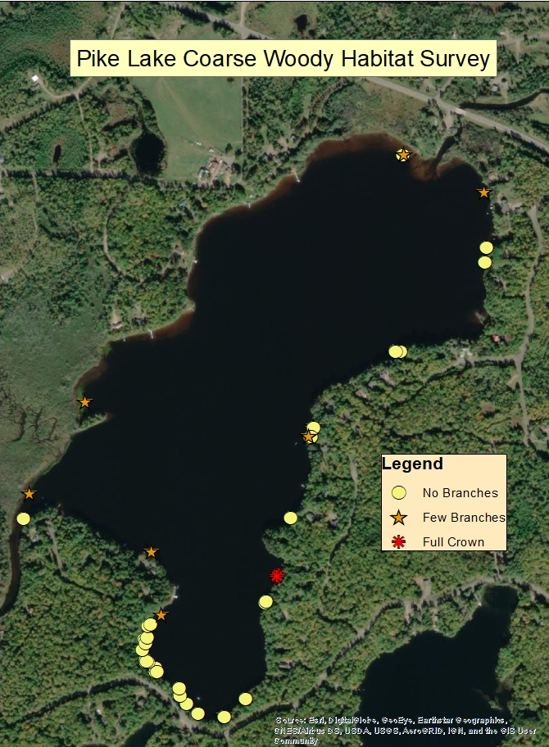

Figure 3: This is a map depicting the type of substrate along the shoreline. There was a substrate sample taken at every location of a CWH and once every 200m.
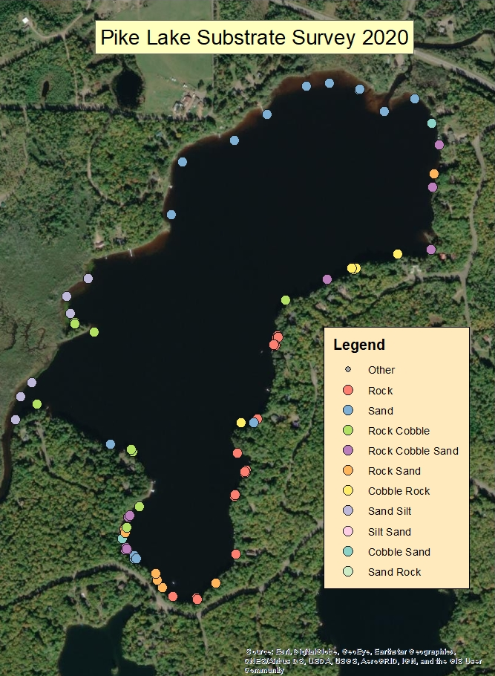

Figure 4: CWH based off miles of shoreline and acres
Number of CWH | Trees with crowns | acres | miles | CWH/mile | crowns/mile | CWH/acre | crowns/acre
49 | 4 | 214 | 2.95 | 16.61 | 1.36 | 0.23 | 0.019

Chart 2: A lakes substrate near the shore is a critical place for many spawning fish. Fish biologists have antidotally seen changes in siltation in traditional spawning areas and documentation is critical to understanding these changes. Pike Lake is made up of a large amount of rock and cobble which are prime locations for walleyes to spawn. Rock was 40% and cobble was 21%. Sand and Silt were 33% and 6% respectively.

Rock Substrate | Cobble Substrate | Sand Substrate | Silt Substrate
68.92 | 35.14 | 55.41 | 10.81

